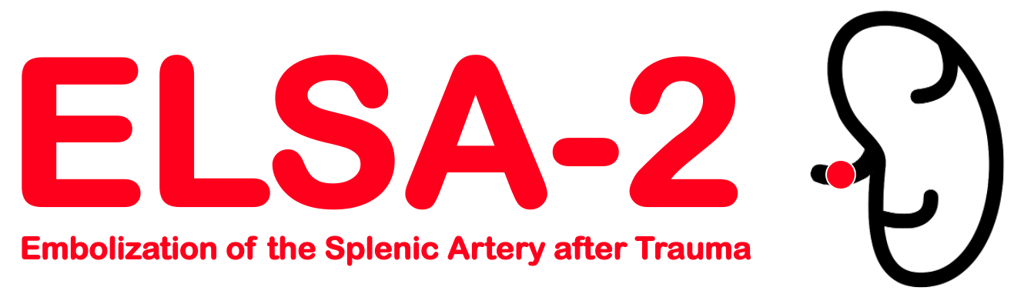
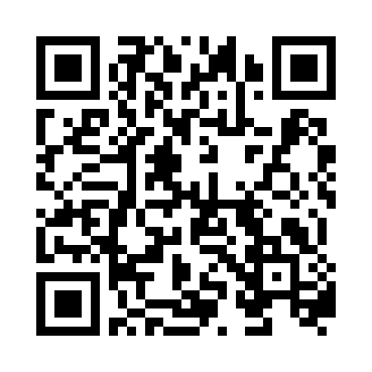
Scan with camera for direct link to REDCap database or use link:

https://redcap.dom.uab.edu/redcap_v12.2.10/index.php?pid=985

ONLY PI or Sub-I consent subjects
- Clean ready to use consents are located inside cabinet.
- Please put signed consents in pink binder and write subject info in log.
- Put a post it note on screen fail consents to inform coordinator.
- ELSA2@uabmc.edu or 205-996-1082.
Principal Investigators | Sub-Investigators | Coordinators
Andrew Gunn, MD | UAB Site PI-
Jan Jansen, MD

