
UAB ASME’s 35rd Annual Brent Newman Memorial
Egg Drop Contest at the Education and Engineering Complex
Friday, April 10, 2026
RULES
I. Instructions for Schools:
- A maximum of 30 devices per school can be registered for the event.
- Individual and group designs are allowed with the exception of no more than 5 students in a group.
- Early registration must be completed and by Friday February 27,2026. Late registration is open through March 13, 2026, but t-shirt and/or goodie bag is not guaranteed. See registration form for details.
- All participating devices must be delivered to UAB no later than Friday, March 27,
2026.
- There must be a parent/teacher/guardian present from your school for every 20 students that attend the event.
- No lunch will be provided. However, it is strongly encouraged that the students bring a packed lunch. Snacks will be available to purchase on-site.
II. Rules for the Design of the Egg Contraption:
- The contraption must be able to protect an egg from breaking after falling 5 stories from the top of the Science and Engineering Complex at UAB.
- The device must not exceed the specific size guidelines depending on the division in which the device is entered:
  - Elementary - 2’ cubic area (2’ x 2’ x 2’)
  - Middle – 1’ cubic area (1’ x 1’ x 1’)
  - High – 8” cubic area (8” x 8” x 8”)
- No device can weigh more than 1 kg (2.2 lbs). *IMPORTANT: Devices weighing more than 1 kg will not be dropped as they present a safety concern to event attendees and volunteers.
- The following requirements are given for the loading of the device:
  - The devices should not be loaded with an egg before the competition.
  - All devices should be designed to be easily loaded by a third party at the competition, i.e. within l minute or less. (This factor is part of the judging criterion).
iii. If there are special instructions for loading the device, these instructions should be provided on a regular 8.5” x 11” sheet of paper along with the student’s name(s), school name, teacher’s name, and grade and taped to the device.
- The following materials are not allowed in the design:
  - Parachutes. Designs will be attached to a guide wire, so they must be able to free fall without interference. The guide wire will be at an angle approximately 10° from vertical.
  - Packing peanuts, glitter, confetti, sequins, beads, etc.
  - Metals, glass, chemical containers, Styrofoam (with the exception of whole Styrofoam cups), and thick wood (such as a 2x4).
  - Any substance that will splatter, such as food or liquids.
- Attach a zip tie to the device so that it may be connected to the guide wire. See Figure 1 as an example.
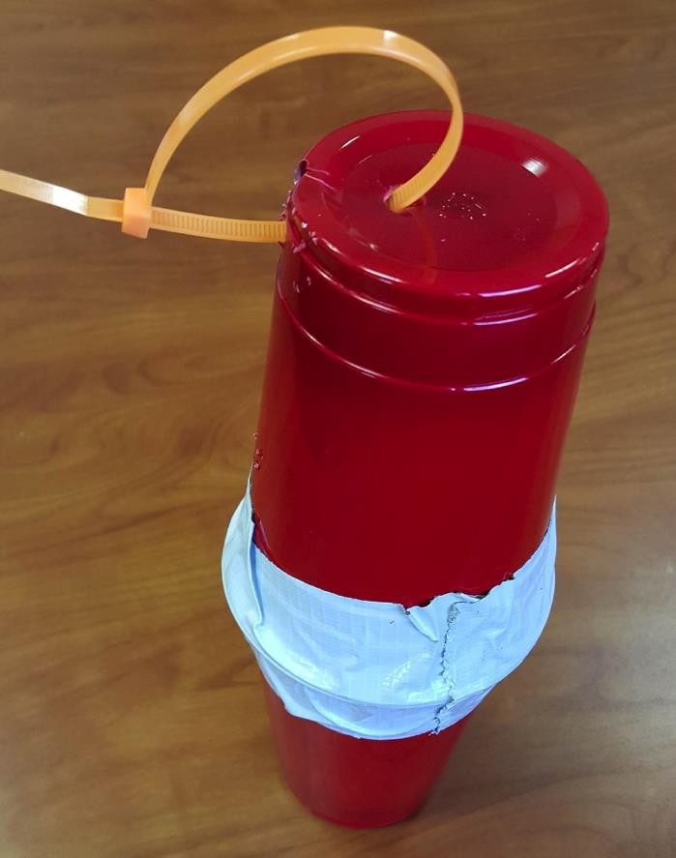
Figure 1
- The contraption must be built before the students arrive at the competition.
- All devices must have the following information on the device: student’s name(s), school name, teacher’s name, and grade.
III. Judging Criterion:
- Awards will be given in the following categories:
  - Elementary School
  - Middle School
  - High School
- The judging of the egg drop devices will be performed by a panel of professional engineers and are based on the following weighted criteria:
  - The survivability of the egg upon impact.
1 – Full decimation of the egg
3 – Egg shows cracking but is still held together
5 – Egg is fully intact
ii. The amount of engineering thought and creativity found in the design.* (A spring cushioned egg is better than one surrounded by packing peanuts in a box). Category of entry for each device will be considered during judging.
    - – Device must be fixed by staff prior to event, must be able to be transported without breaking
    - – Device is poorly constructed with little thought into the overall design and functionality
    - – Device is of solid design. Use of regular materials and adequate craftsmanship are present
    - – Device is well thought and conceived. Distinct design features as compared to the average device.
    - – Unique use of materials and well-constructed design - aesthetically stands out from others in competition
*Judges’ discretion will be used to award points, fractional points possible
- The ease of inserting the egg into the device: the easier the device is to operate, the better the design. (Large Grade A eggs to be used)
  - – Egg does not fit in device (modifications will be made by staff to allow the device to be dropped during the event)
  - – Partial disassembling/assembling of device by staff required in order to insert egg (tape roll/ cotton balls provided, multiple toothpicks/straws required to be removed and put back in place etc) Load Time > 30 seconds
  - – Multiple steps needed to insert egg (multiple pieces of tape/ Velcro etc) Load Time < 30 seconds
  - – Only one step required to insert egg (lift tape/lid/Velcro etc and insert)
Load Time < 15 seconds
  - – Device has been designed so that the egg is easily inserted Load Time < 5 seconds
- The weight of the design: the lighter the weight, the better the design. 1 – 3 All devices in a particular category will be weighed and compared to others in the same class. Points will be awarded on a sliding scale with 3 points being the maximum and 1 point awarded minimum.
Dependent on number of entries into each category
- *High school participants only - type a minimum 2 page paper (no maximum),
12 pt. font, double spaced that includes students’ names, teacher’s name, school, date, and title at the top of the first page as well as introduction, design considerations/thought process, calculations, discussion, conclusion, and references sections. The paper will be graded based on completeness, organization, strength and ability of processing and supporting specific design ideas with theory and calculations, and accuracy of mechanics, grammar, and spelling. Only one paper per device/group is necessary. Note: Pictures may be included, but cannot be used to meet the length requirements of the paper.
  - – Paper is not complete, not submitted, or not related to the assignment
  - – Paper lacks a central design idea related to the assignment; lacks clear organization of thoughts; fails to develop/support a specific idea; uses limited vocabulary; and/or has three or more mechanical, grammatical, or spelling errors
  - – Paper has a comprehensible central design idea related to the assignment; is organized in a general manner; includes simplistic support of a specific idea; and only includes one or two severe mechanical, grammatical, or spelling errors
  - – Paper has a strong central design idea related to the assignment; is clear and logically organized, but may not be vivid or thoughtful; includes sufficient theory and calculation to support a specific design idea; and has few mechanical, grammatical, or spelling errors
  - – Paper has a strong central design idea related to the assignment; is clear and logically organized with vivid and thoughtful explanations; includes concrete and specific theory and calculation to support a specific design idea; and is free of mechanical, grammatical, and spelling errors
*Papers must be submitted electronically to UABEggDrop@outlook.com with our ASME Event Chair Vivian Garcia CC: at vrgarcaia@uab.edu by Friday March 27, 2026 to allow enough time for grading.
IV. Changes to the Rules:
- Rules may be changed up until Wednesday March 4, 2026 due to scheduling concerns or number of participants.
- Any changes to the rules will be communicated by email and/or fax.
If your school is interested in participating in this event, please contact UAB ASME, Event Chair,
Vivian Garcia at vrgarcia@uab.edu

