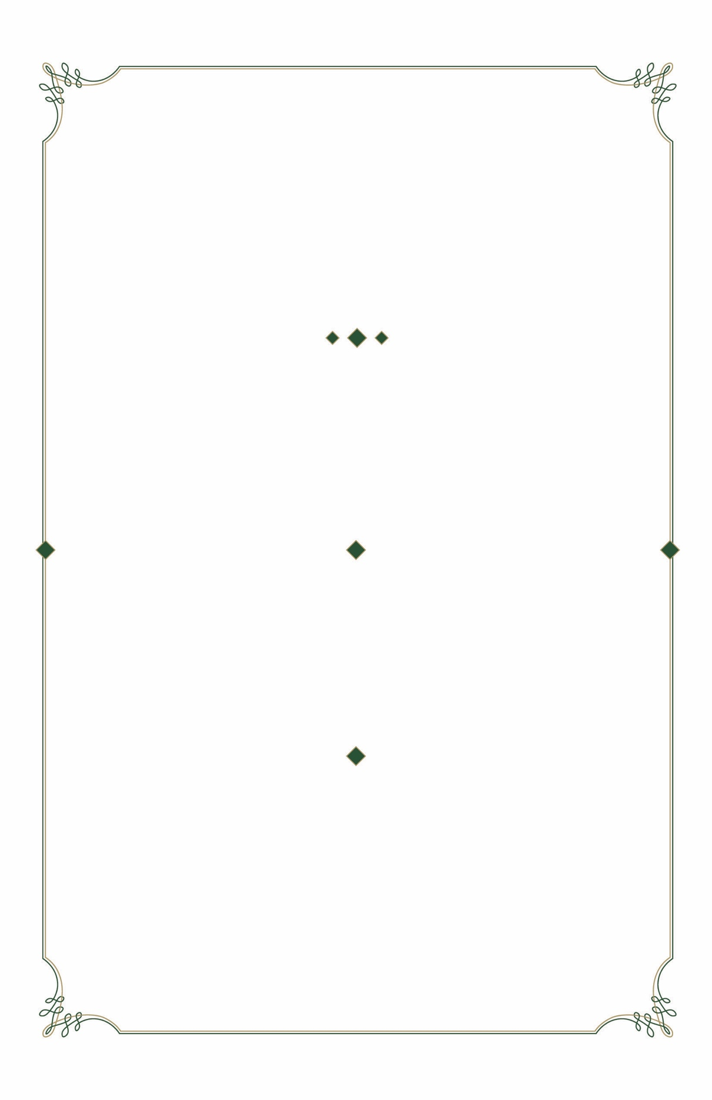
invite you to attend

A DONOR APPRECIATION RECEPTION

To thank you for your
generous support of

T H E U N I V E R S I T Y O F
A L A B A M A A T B I R M I N G H A M

invite you to attend

A DONOR APPRECIATION RECEPTION

To thank you for your
generous support of

T H E U N I V E R S I T Y O F
A L A B A M A A T B I R M I N G H A M

W E D N E S D A Y
N O V E M B E R 2 9, 2 0 1 8

6 : 0 0 PM – 8 : 0 0 PM

U A B W O O D W A R D H O U S E
4 1 0 1 A L T A M O N T R O A D

W E D N E S D A Y
N O V E M B E R 2 9, 2 0 1 8

6 : 0 0 PM – 8 : 0 0 PM

U A B W O O D W A R D H O U S E
4 1 0 1 A L T A M O N T R O A D

please reply to 205.975.0756
or uabevents@uab.edu

BUSINESS ATTIRE
VALET PARKING AVAILABLE


P R E S I D E N T & M R S . R A Y L . W A T T S

T H E U N I V E R S I T Y O F
A L A B A M A A T B I R M I N G H A M

P R E S I D E N T & M R S . R A Y L . W A T T S

T H E U N I V E R S I T Y O F
A L A B A M A A T B I R M I N G H A M

please reply to 205.975.0756
or uabevents@uab.edu

BUSINESS ATTIRE
VALET PARKING AVAILABLE

